Pandit Deendayal Energy University

School of Technology

Department of Computer Science and Engineering

Odd Semester 2023-2024 (July-Nov 2023)

Course Student Handout

INDEX

|  |  |  |
| --- | --- | --- |
| **Name of the course:** Discrete Mathematical Structures | | **Course Code:** 20MA206T |
| **Program:** Bachelor of Technology  **Branch:** Computer Science and Engineering | | **Semester:** III  **Academic Year:** 2023-2024 |
| **Name of Course Coordinator**: Dr. Kocherlakota Satya Pritam | | |
| **Subject Teachers (Division wise/Batch wise): G1, G2, G3, G4, G5, G6** | | |
| 1 | Departmental Vision & Mission | |
| 2 | Program educational objectives (PEOs) of Department | |
| 3 | Program Outcomes (POs) | |
| 4 | Program Specific Outcomes (PSOs) | |
| 5 | Academic Calendar | |
| 6 | Class Time Table with office hours | |
| 7 | Course Outcomes (COs), Course Syllabus, Pre requisites for the course | |
| 8 | Lesson Plan | |
| 9 | Program Articulation Matrix and Course Articulation Matrix | |
| 10 | Evaluation Scheme and Rubrics | |
| 11 | Tutorials, Assignments, Case Studies, Quiz, Presentations etc. | |
| 12 | Copy of Sessional Mid and End semester Examination Question Papers | |
| 13 | Course covered beyond syllabus and self-study topics | |

Date: July 24, 2023

|  |  |  |
| --- | --- | --- |
| Dr. Kocherlakota Satya Pritam Signature of Subject Teachers | Dr. J. Brahma  Signature of Department Coordinator (IQAC) | Dr. Poonam Mishra  Signature of Head of the Department |
|  |  |  |

**Department of Computer Science and Engineering**

**Sr. No. 1:**

**Departmental Vision & Mission**

**Vision**

Produce globally competent and employable Computer Science and Engineering having skills to innovate and to have core values. To be a legendary & valued department by imparting quality education & training based on the futuristic research & innovations.

**Mission**

The Department of Computer Science and Engineering at SOT, PDPU will be constantly energizing to attain high-impact research and to be trained about the latest developments in the continually creating field of Computer Science and Engineering. The department will guarantee that students graduate knows the essentials of Computer Science and Engineering. We will be an astounding department as measured by the:

* Impact of our research.
* Quality of our teaching.
* Great readiness of our graduates for leadership in the profession and in advanced education.

**Sr. No. 2:**

**Program Educational Objectives (PEOs):**

The Programme Educational Objectives of B. Tech. Computer Science and Engineering are:

1. To prepare graduates who will be successful professionals in industry, government, academia, research, entrepreneurial pursuit and consulting firms
2. To prepare graduates who will make technical contribution to the design, development and production of computing systems
3. To prepare graduates who will get engage in lifelong learning with leadership qualities, professional ethics and soft skills to fulfill their goals
4. To prepare graduates who will adapt state of the art development in the field of computer engineering

**Sr. No. 3:**

**Program Objectives (POs):**

**Engineering Graduates will be able to:**

1. **Engineering knowledge**: Apply the knowledge of mathematics, science, engineering fundamentals, and an engineering specialization to the solution of complex engineering problems.
2. **Problem analysis**: Identify, formulate, review research literature, and analyze complex engineering problems reaching substantiated conclusions using first principles of mathematics, natural sciences, and engineering sciences.
3. **Design/development of solutions**: Design solutions for complex engineering problems and design system components or processes that meet the specified need with appropriate considerations for public health and safety, and the cultural, societal and environmental considerations.
4. **Conduct investigations of complex problems**: Use research-based knowledge and research methods including design of experiments, analysis and interpretation of data, and synthesis of the information to provide valid conclusions.
5. **Modern tool usage**: Create, select and apply appropriate techniques, resources, and modern engineering and IT tools including prediction and modeling to complex engineering activities with an understanding of the limitations.
6. **The engineer and society**: Apply reasoning informed by the contextual knowledge to assess societal, health, safety, legal and cultural issues and the consequent responsibilities relevant to professional engineering practices.
7. **Environment and sustainability**: Understand the impact of the professional engineering solutions in societal and environmental context, and demonstrate the knowledge of, and need for sustainable development.
8. **Ethics**: Apply ethical practices and commit to professional ethics and responsibilities and norms of the engineering practice.
9. **Individual and team work**: Function effectively as an individual, and as a member or leader in diverse teams and in multidisciplinary settings.
10. **Communication**: Communicate effectively on complex engineering activities with the engineering community and with society at large, such as, being able to comprehend and write effective reports and design documentation, make effective presentations, and give and receive clear instructions.
11. **Project management and finance**: Demonstrate knowledge and understanding of the engineering and management principles and apply these to one′s own work, as a member and leader in the team, to manage projects and in multidisciplinary environments.
12. **Life-long learning:** Recognize the need for, and have the preparation and ability to engage in independent and life-long learning of broadest context of technological change.
13. Design and innovate computing systems addressing diverse needs in the domain of application development, communication, computation, algorithms and hardware & software.
14. Pursue higher education and research career.

**Sr. No. 4:**

**Program Specific Outcomes (PSOs):**

The graduates of CSE department will be able to:

1. Develop computer engineering solutions for specific needs in different domains applying the knowledge in the areas of programming, algorithms, hardware-interface, system software, computer graphics, web design, and networking and advanced computing.

2. Analyze and test computer software designed for diverse needs.

3. Pursue higher education.

**Sr. No. 5: Academic Calendar**

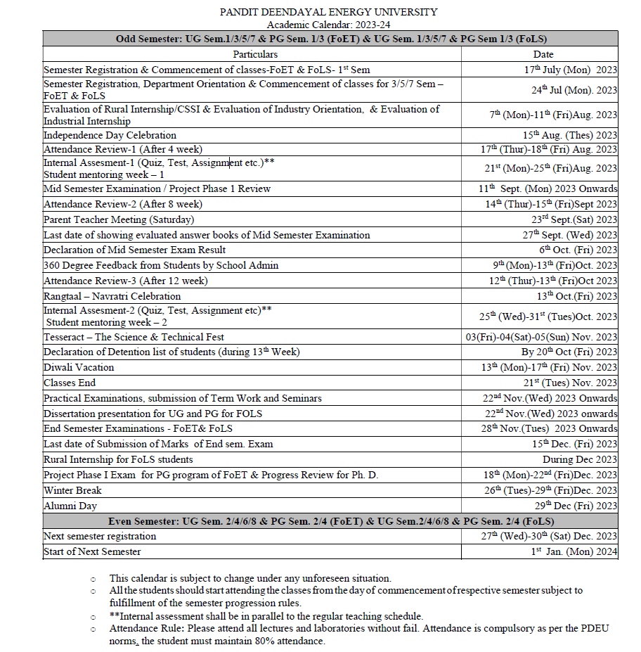

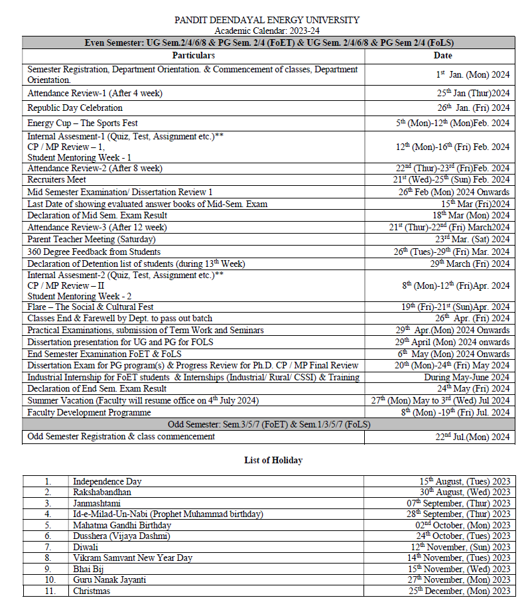

**Sr. No. 6(A): Class Time table with office hours**

**Division 1:**

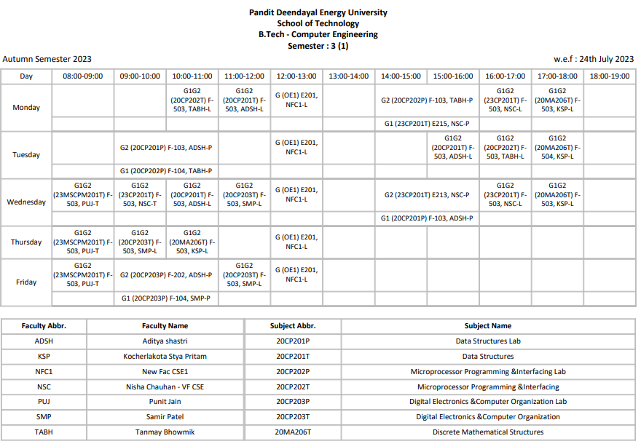

**Office hours for division 1: Tuesday, 2 to 3 pm**

**Division 2:**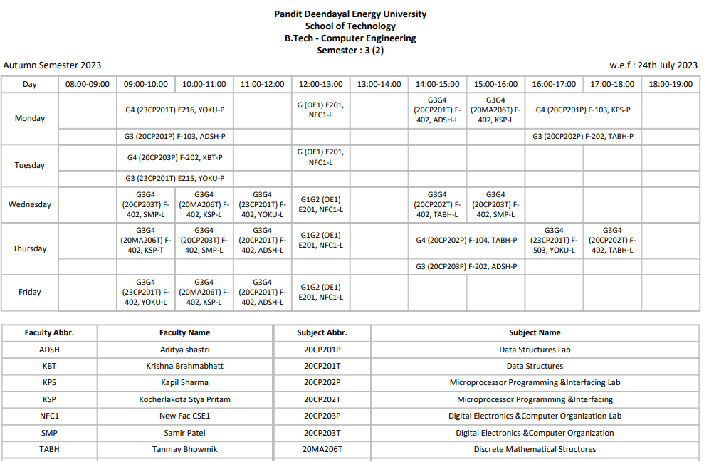

**Office hours for division 2: Tuesday, 2 to 3 pm**

**Division 3:**

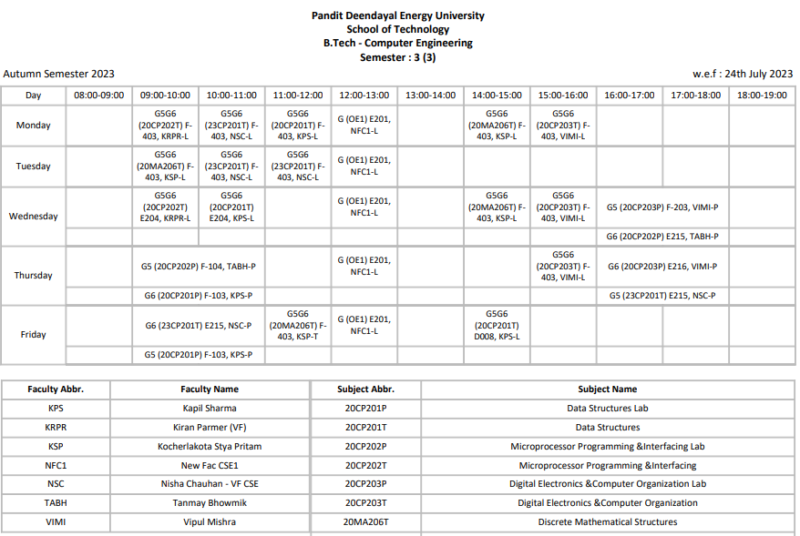

**Office hours for division 3: Tuesday, 2 to 3 pm**

**Sr. No. 6(B): Faculty Time table**

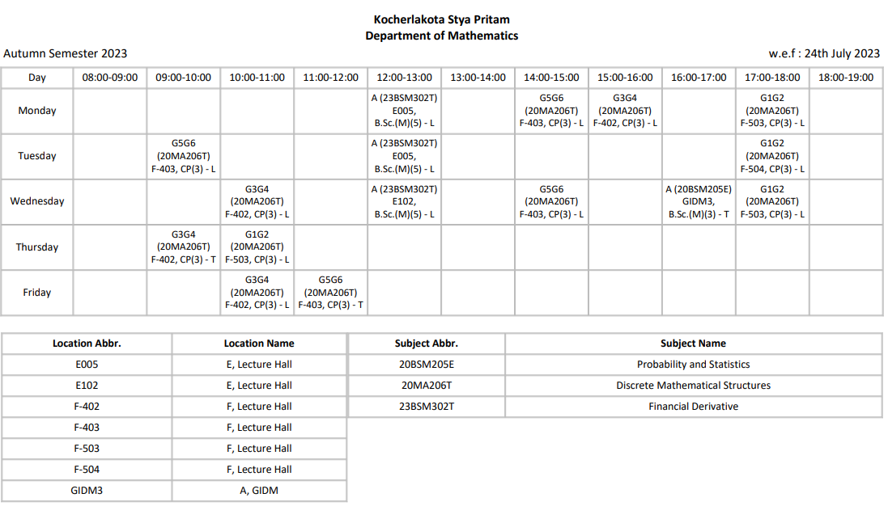

**Sr. No. 7.** **Course Outcomes (COs), Course Syllabus, Pre requisites for the course**

Course code: 20MA206T, Course name: Discrete Mathematical Structures

7.1 Course Outcomes (CO's):

On completion of the course, student will be able to

CO1 – Remember the basics of counting and combinatorics.

CO2 – Understand the basic concepts of sets, relations, functions, logic and be able to determine their properties.

CO3 – Model and solve the real life problem using recurrence relations.

CO4 – Apply Graph theory in related areas such as shortest path problems and network flow problems.

CO5 – Defend and point out fallacious reasoning and propositions in algebraic structures.

CO6 – Model and solve any given engineering problem involving graphs and trees.

7.2 Course syllabus

|  |  |
| --- | --- |
| UNIT 1 SETS, RELATIONS, FUNCTIONS AND LOGIC | 10 Hrs. |
| Finite and Infinite sets, Counting Principle, Countable and Uncountable sets, Mathematical Induction, Relations, Types of Relation, Partial Ordered Relations, Logic and Propositional calculus – Propositions and Compound statements, Basic logical operators. Truth tables. Tautologies, Contradictions, logical equivalence, conditional and bi-conditional statements. Valid arguments and Fallacy. Hasse diagram and Lattice. | |
| UNIT 2 COMBINATORICS | 10 Hrs. |
| Counting principles, Permutation, Combination, Pigeonhole principle, Extended Pigeonhole principle, inclusion-exclusion principle. Recurrence relations, Linear recurrence relations with constant coefficients, Solutions of recurrence relations: second order homogeneous linear recurrence relation, general homogeneous linear recurrence relation. | |
| UNIT 3 GRAPH THEORY AND ITS APPLICATIONS | 12 Hrs. |
| Graphs and related definitions, Sub graphs, Homomorphism and Isomorphism, Paths and Connectivity. Traversable and Eulerian graphs, and Konigsberg Bridge problem, Hamiltonian graphs, Labeled and weighted graphs. Complete, regular and bipartite graphs, Tree graphs, planar graphs, Graph coloring. Four color problem. Directed graphs, Strongly and weakly connected graphs rooted trees, sequential representation of directed graphs, Adjacency matrix, Powers of the adjacency matrix, Warshall algorithm, and Floyd-Warshall algorithm for shortest path. Linked representation of directed graphs. Graph algorithms: Depth first and Breadth first searches. Binary trees, Algebraic expressions and Polish notation. | |
| UNIT 4 ALGEBRAIC STRUCTURES | 08 Hrs. |
| Group, Semi group, Monoids, Properties of a Group, Composition table for finite Group, Order of a group, Order of its elements, Cyclic Group, Generator, Lagrange’s Theorem. Ring, Properties of Rings, Integral Domain, Field. | |
|  | |

TEXT / REFERENCE BOOKS

1. Seymour Lipschutz and Marc Lipson, Discrete Mathematics, Schaum’s Series, 3rd ed., McGraw-Hill Education, 2009.

2. Kenneth Rosen, Discrete Mathematics and Its Applications, 7th ed., McGraw Hill Education, 2017.

3. Bernard Kolman, Robert Busyb and Sharon C. Ross, Discrete Mathematical Structures, 6th ed., Pearson, 1998.

4. Thomas Koshy, Discrete Mathematics with Applications, Academic Press Inc., 2004.

5. Ralph P. Gramaldi, Discrete and Combinatorial Mathematics, 5th ed., Pearson, 2006.

6. C.L. Liu, D.P. Mohapatra, Elements of Discrete Mathematics: A Computer Oriented Approach, 4th ed., McGraw Hill Education, 2017.

7.3 Prerequisites

Basic set theory and mathematical logic.

**Sr. No. 8.** **Lesson Plan**

|  |  |
| --- | --- |
| Lesson Plan | |
| Name of the course: Discrete Mathematical Structures | Course Code: 20MA206T |
| Program: B.Tech.  Branch: Computer Science and Engineering | Semester: III  Academic Year: 2021-2022 |
| Name of Course Coordinator: Dr. Kocherlakota Satya Pritam | |
| Subject Teachers (Division wise/Batch wise):  Division 1, Division 2, Division 3: Dr. Kocherlakota Satya Pritam | |

|  |  |  |
| --- | --- | --- |
| Topic Planned | Lectures Required | Remarks (Text book/Unit No etc.) |
| Introduction to the course and understanding course handout | 1 |  |
| UNIT 1 |  | Seymour Lipschutz and Marc Lipson, Discrete Mathematics, Schaum’s Series, 3rd ed., McGraw-Hill Education, 2009. |
| Finite and Infinite sets, Counting Principle | 1 |
| Countable and Uncountable sets, Mathematical Induction | 1 |
| *Tutorial* | *1* |
| Relations, Types of Relation, Partial Ordered Relations | 1 |
| Logic and Propositional calculus – Propositions and Compound statements, Basic logical operators. Truth tables. | 1 |
| Tautologies, Contradictions, logical equivalence | 1 |
| *Tutorial* | *1* |
| Conditional and bi-conditional statements | 1 |
| Valid arguments and Fallacy | 1 |
| Hasse diagram and Lattice | 2 |
| Tutorial | *1* |
|  |  |
| UNIT 2 |  |
| Counting principles, Permutations, Combinations | 2 |
| Pigeonhole principle, Extended Pigeonhole principle | 1 |
| *Tutorial* | *1* |
| Inclusion-exclusion principle. | 1 |
| Recurrence relations, Linear recurrence relations with constant coefficients | 1 |
| Solutions of recurrence relations: second order homogeneous linear recurrence relation, general homogeneous linear recurrence relation. | 2 |
| *Tutorial* | *1* |
|  |  |
| UNIT 3 |  |
| Graphs and related definitions, Sub graphs | 1 |
| Homomorphism and Isomorphism, Paths and Connectivity | 1 |
| Traversable and Eulerian graphs, and Konigsberg Bridge problem, Hamiltonian graphs | 1 |
| *Tutorial* | *1* |
| Labeled and weighted graphs. Complete, regular and bipartite graphs,Tree graphs, | 1 |
| Planar graphs, Graph coloring. Four color problem | 1 |
| Directed graphs, Strongly and weakly connected graphs | 1 |
| *Tutorial* | *1* |
| Rooted trees, sequential representation of directed graphs | 1 |
| Adjacency matrix, Powers of the adjacency matrix | 1 |
| Warshall algorithm, and Floyd-Warshall algorithm for shortest path | 2 |
| *Tutorial* | *1* |  |
| Linked representation of directed graphs | 1 |  |
| Graph algorithms: Depth first and Breadth first searches. | 1 |  |
| Binary trees, Algebraic expressions and Polish notation | 1 |  |
|  |  |  |
| UNIT 4 |  |  |
| Group, Semi group, Monoids, Properties of a Group | 2 | J. A. Gallian, Contemporary Abstract Algebra, 8th ed., Cengage publisher, 2012. |
| Composition table for finite Group, Order of a group | 1 |
| *Tutorial* | *1* |
| Order of its elements, Cyclic Group | 1 |
| Generator, Lagrange’s Theorem. Ring | 1 |
| Properties of Rings, Integral Domain, Field. | 2 |
| *Tutorial* | *1* |
|  |  |  |
| Total required lecture and tutorial hours | **43** |  |

**Sr. No. 9.** **Program Articulation Matrix and Course Articulation Matrix**

Course Articulation Matrix

|  |  |  |  |  |  |  |  |  |  |  |  |  |  |  |  |  |  |
| --- | --- | --- | --- | --- | --- | --- | --- | --- | --- | --- | --- | --- | --- | --- | --- | --- | --- |
|  | PO1 | PO2 | PO3 | PO4 | PO5 | PO6 | PO7 | PO8 | PO9 | PO10 | PO11 | PO12 | PO13 | PO14 | PS01 | PSO2 | PSO3 |
| CO 1 | 2 | 2 |  | 2 |  |  |  |  | 1 |  |  | 1 |  | 1 | 3 |  | 1 |
| CO 2 | 2 | 2 | 1 | 3 |  |  |  |  | 2 |  |  | 1 |  | 1 | 3 |  | 2 |
| CO 3 | 3 | 3 | 2 | 2 | 1 |  |  |  | 2 |  | 2 | 1 |  | 1 | 3 |  | 2 |
| CO 4 | 3 | 3 |  | 3 |  |  |  |  | 2 |  | 3 | 1 |  | 2 | 3 | 1 | 2 |
| CO 5 | 2 | 3 | 2 | 2 | 1 |  |  |  | 2 |  |  | 1 |  | 1 | 3 |  | 2 |
| CO 6 | 3 | 2 |  | 3 | 1 |  |  |  | 2 |  |  | 2 |  | 2 | 3 | 1 | 2 |

Program Articulation Matrix

|  |  |  |  |  |  |  |  |  |  |  |  |  |  |  |  |  |
| --- | --- | --- | --- | --- | --- | --- | --- | --- | --- | --- | --- | --- | --- | --- | --- | --- |
| PO1 | PO2 | PO3 | PO4 | PO5 | PO6 | PO7 | PO8 | PO9 | PO10 | PO11 | PO12 | PO13 | PO14 | PS01 | PSO2 | PSO3 |
|  |  |  |  |  |  |  |  |  |  |  |  |  |  |  |  |  |

Correlation levels 1, 2 or 3 as defined below:

1: Slight (Low) 2: Moderate (Medium) 3: Substantial (High)

**Sr. No. 10. Evaluation Scheme and Rubrics**

10 (A) Evaluation scheme:

For evaluation of the course, 25% weightage will be given to the   
Mid Semester Examination, 25% weightage will be given to the Internal Assessment and 50% weightage will be given to the End Semester Exams.

10(B) Rubrics

|  |  |  |  |
| --- | --- | --- | --- |
| Sr. No. | Component | Associated Course outcomes | Mode of exam |
| 1 | Mid semester examination (25 marks) [This will be a 50 marks question paper] | CO1, CO2, CO3, CO5 | Offline examination |
| 2 | End-semester examination (50 marks) [This will be a 100 marks question paper] | CO1, CO2, CO3, CO4, CO5, CO6 | Offline examination |
| 3 | Continuous assessment (Internal assessment)  (25 marks) | CO1, CO2, CO3, CO4, CO5, CO6 | Assignments, quiz, presentations, submissions. |

Components of internal assessment (25 marks)

|  |  |  |  |
| --- | --- | --- | --- |
| Continuous assessment (Internal assessment)  (25 marks) | Assignment on Unit 1 and 2: CO1, CO2, CO3, CO5 | 5 marks | 21st to 25th August 2023 (IA1 week) |
| Quiz: CO1, CO2, CO3, CO5 | 5 marks |
| Assignment on Unit 3 and 4: CO4, CO6 | 5 marks | 25th to 31st October 2023 (IA2 week) |
| DMS based application assignment/presentation.  It should demonstrate the applicability of the concept of DMS to real life/engineering/science (CO6) | 10 marks |

**Sr. No. 11. Tutorials, Assignments, Quiz, Presentations etc.**



Assignment-3 will be provided soon.



**Sr. No. 12** Copy of Sessional Mid and End semester Examination Question Papers

NA

**Sr. No. 13**. Course covered beyond syllabus and self-study topics: Rooted trees, sequential representation of directed graphs, and Linked representation of directed graphs, Graph algorithms: Depth first and Breadth first searches, Binary trees, Algebraic expressions and Polish notation,